Instructions on how to install HD5T Load Bars under a SC25 Chute that does not have pre-drilled holes for the Scale application.

The first 25-SC25 Model squeeze chutes that were produced were not equipped to be able to put Scale Load Bars under them.
We have designed the HD5TB25 to be able to install the Tru-Test HD5T load bars under these chutes.
Since the first 25 chutes did not have the holes drilled in the floor of the chutes, we have also designed the HD5T25T (template) to send to customers that have these chutes but want to put scales under the chute. There is a template for the front of the chute that is flat. This template should be placed so that the rumber floor is centered in the template and the front of the template should be touching the flat bar that is welded to the chute floor. (see picture) There is a separate template for the back of the chute that has a lip on the outside edge. This template is to be placed so the rumber floor is centered in the template and the lip that is bent down should be slid up against the back of the chute floor. (see picture)

Once these templates are in place you will be able to cut the holes in the floor in the correct place to be able to bolt the HD5TB25 in place. These holes (especially on the back of the chute) are probably best cut with a torch because where some of the holes need to be it is almost impossible to get a drill bit lined up.

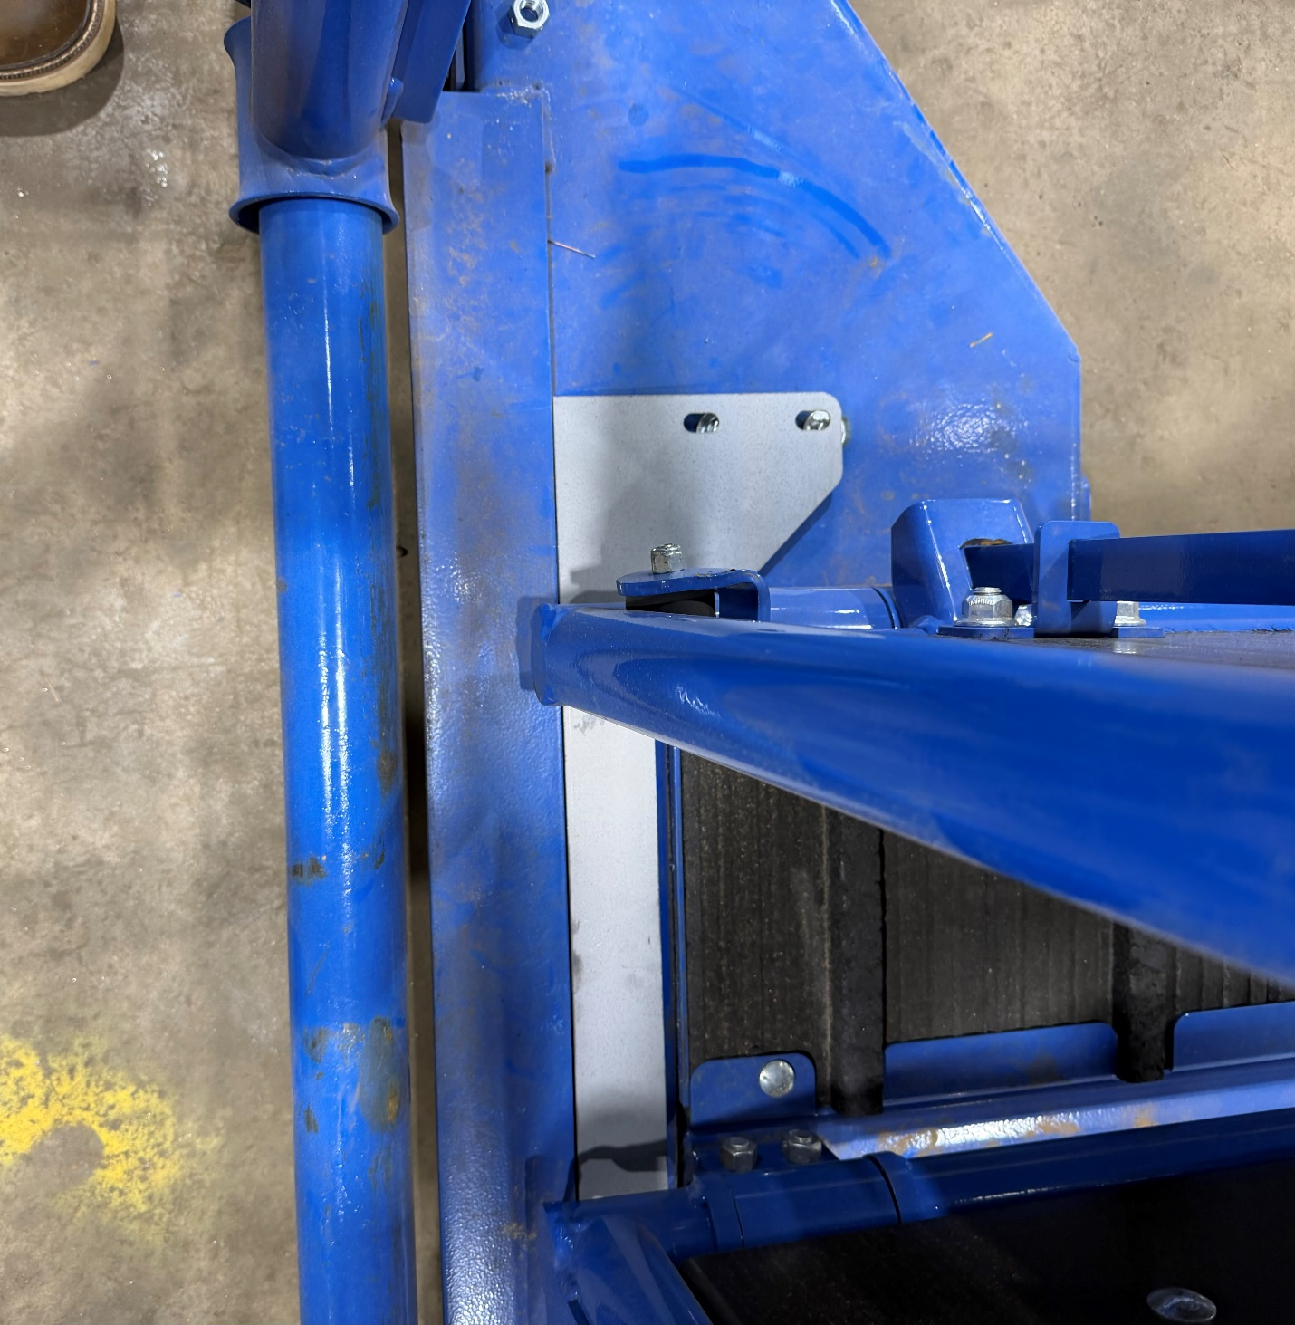
Front Bracket Template
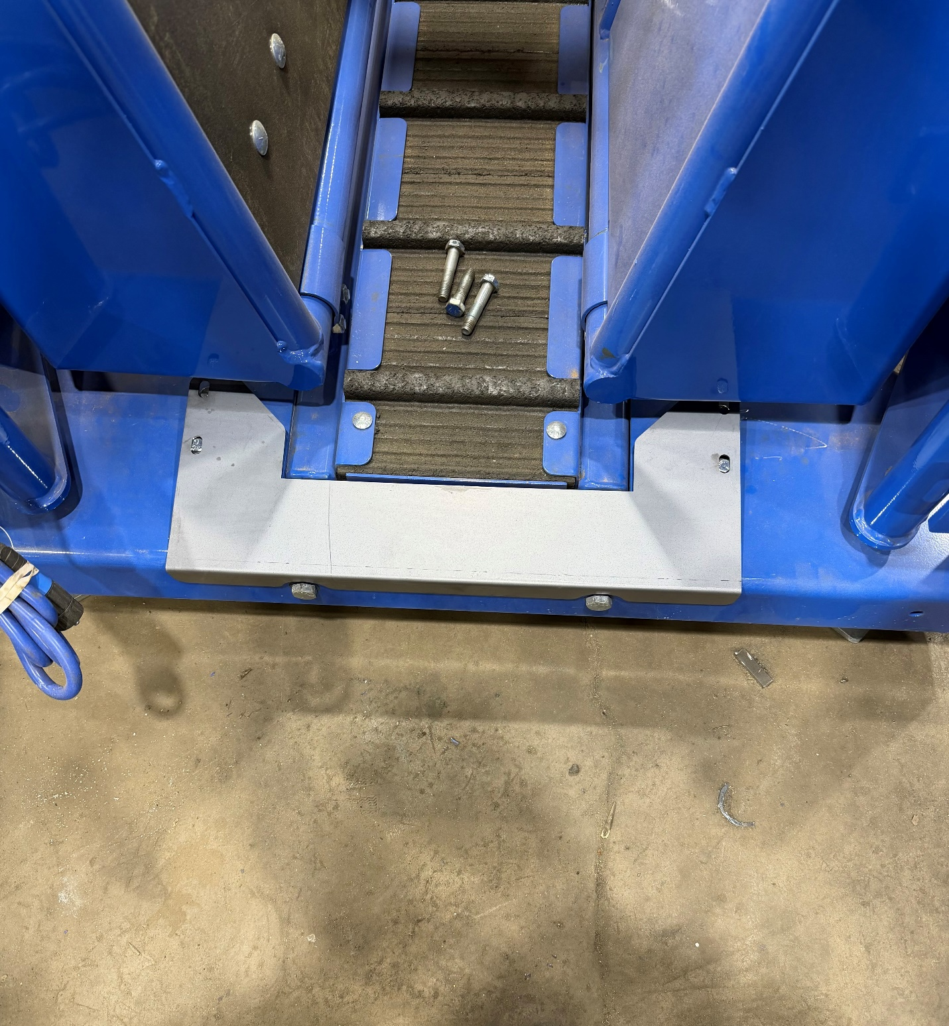

Back Bracket Template

